Assignment 2 : Implement Constraint Satisfaction Problem (CSP)

Problem Statement:
The goal of this assignment is to solve a constraint satisfaction problem (CSP) like Sudoku using backtracking. You will learn to represent the problem, define its constraints, and implement an algorithm to find a valid solution.

Objectives:
- Learn to represent and solve CSPs.
- Implement backtracking to find solutions effectively.

Theory

What is a CSP?
A CSP consists of:
- Variables: Elements that need to be assigned values (e.g., cells in Sudoku).
- Domains: The set of possible values each variable can take (e.g., numbers 1-9 for Sudoku).
- Constraints: Rules that dictate how variables can be assigned values (e.g., no two cells in the same row, column, or sub-grid can have the same value in Sudoku).

Methodology
- Define Variables, Domains, and Constraints:
  - For a Sudoku puzzle, each cell is a variable.
  - The domain for each variable is the numbers 1 to 9.
  - Constraints ensure that no two variables in the same row, column, or 3x3 sub-grid can have the same value.
- Start with an Empty Assignment:
  - Initialize an empty grid for Sudoku where you will assign values to variables.
- Use Backtracking:
  - Assign a value to a variable and check if the assignment satisfies all constraints.
  - If it does, move to the next variable.
  - If it does not, backtrack and try a different value for the previous variable.
  - This process continues until a valid solution is found or all possibilities are exhausted.
- Continue Until a Valid Solution is Found:
  - If a valid configuration of the entire grid is reached, output the solution.
  - If no solution is possible, indicate that as well.

Working Principle / Algorithm
Here’s a basic outline of the backtracking algorithm to solve Sudoku:
- Find the Next Empty Cell:
  - Scan the grid for the next cell that needs a value.
- Try Each Possible Value:
  - For each number from 1 to 9:
    - Assign the number to the empty cell.
    - Check if the assignment is valid (i.e., it does not violate any Sudoku constraints).
    - If valid, recursively call the function to assign values to the next cell.
- Backtrack If Necessary:
  - If the recursive call leads to a solution, propagate that solution upwards.
  - If not, reset the cell and try the next number.
- End Condition:
  - If all cells are filled correctly, the puzzle is solved.

Advantages
- Structured Approach: CSPs provide a clear framework to structure problems using variables, domains, and constraints.
- Effective for Many Variables: The backtracking algorithm is particularly effective for problems with numerous variables and complex constraints.

Disadvantages / Limitations
- Performance: Backtracking can be computationally expensive and slow for large CSPs, particularly as the number of variables and constraints increases.
- Exponential Time Complexity: The worst-case time complexity can grow exponentially with the size of the problem.

Diagram

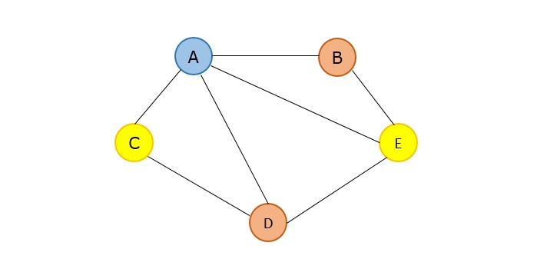

Conclusion
CSPs offer a systematic way to approach complex problems by framing them in terms of constraints. The backtracking technique allows us to explore possible assignments efficiently, making it a valuable tool for solving problems like Sudoku and many others.

Code :-
import java.util.*;

public class color_mapping {

static List<String> regions = new ArrayList<>();
static Map<String, List<String>> adjacency = new HashMap<>();
static List<String> colors = new ArrayList<>();

// Check if assigning a color is valid
static boolean isValid(Map<String, String> assignment, String region, String color) {
for (String neighbor : adjacency.get(region)) {
if (assignment.get(neighbor) != null && assignment.get(neighbor).equals(color)) {
return false; // Neighbor has same color
}
}
return true;
}

// Backtracking function
static boolean solveColoring(int index, Map<String, String> assignment) {
if (index == regions.size()) {
return true; // All regions assigned
}

String region = regions.get(index);
for (String color : colors) {
if (isValid(assignment, region, color)) {
assignment.put(region, color);
if (solveColoring(index + 1, assignment)) {
return true;
}
assignment.put(region, null); // Backtrack
}
}
return false;
}

public static void main(String[] args) {
Scanner sc = new Scanner(System.in);

// Input regions
System.out.print("Enter number of regions: ");
int n = sc.nextInt();
System.out.println("Enter region names:");
for (int i = 0; i < n; i++) {
regions.add(sc.next());
}

// Input colors
System.out.print("Enter number of colors: ");
int m = sc.nextInt();
System.out.println("Enter color names:");
for (int i = 0; i < m; i++) {
colors.add(sc.next());
}

// Input adjacency list
System.out.println("Enter adjacency list (neighbors for each region):");
for (String region : regions) {
System.out.print("Number of neighbors of " + region + ": ");
int k = sc.nextInt();
List<String> neighbors = new ArrayList<>();
System.out.println("Enter neighbors of " + region + ":");
for (int j = 0; j < k; j++) {
neighbors.add(sc.next());
}
adjacency.put(region, neighbors);
}

// Initialize assignment
Map<String, String> assignment = new HashMap<>();
for (String r : regions) {
assignment.put(r, null);
}

// Solve
if (solveColoring(0, assignment)) {
System.out.println("\nSolution found:");
for (String r : regions) {
System.out.println(r + " -> " + assignment.get(r));
}
} else {
System.out.println("\nNo solution exists.");
}

sc.close();
}
}

Output :-
Enter number of regions: 4
Enter region names:
A B C D
Enter number of colors: 3
Enter color names:
Red Green Blue
Enter adjacency list (neighbors for each region):
Number of neighbors of A: 2
Enter neighbors of A:
B C
Number of neighbors of B: 3
Enter neighbors of B:
A C D
Number of neighbors of C: 3
Enter neighbors of C:
A B D
Number of neighbors of D: 2
Enter neighbors of D:
B C

